NAME- SIDDHESH DILIP KHAIRNAR

ROLL NO- 1421

DIVISION- N

PRN NO- 22110398

**BEE TERM WORK**

### EXPERIMENT NO.1

**Study of safety precautions and measuring instruments**

**1.6 Study of resistors, capacitors and inductors**

|  |  |  |  |
| --- | --- | --- | --- |
| **Sr. No.** | **Color Code** | **Tolerance (%)** | **Resistance Value (KΩ)** |
| 1 | Red, Black, Yellow, Gold | 5% | 200 KΩ |
| 2 | Brown, Black, Orange, Gold | 5% | 10KΩ |
| 3 | Yellow, Violet, Red, Silver | 10% | 4.7KΩ |

### EXPERIMENT NO.3

### Verification of Kirchhoff’s Laws and Superposition Theorem

* 1. **Result Table:**

|  |  |  |  |  |  |  |  |  |
| --- | --- | --- | --- | --- | --- | --- | --- | --- |
| **Sr. No.** | **E1 (volts)** | **E2 (volts)** | **I1 (mA)** | **V1 (V)** | **I2 (mA)** | **V2 (V)** | **I3 (mA)** | **V3 (V)** |
| 1 | 21 | 0 | 252 | 12.6 | 168 | 8.4 | 84 | 8.4 |
| 2 | 0 | 24 | 192 | 9.6 | 288 | 14.4 | 96 | 9.6 |
| 3 | 21 | 24 | 60 | 3 | -120 | -6 | 180 | 18 |

* 1. **Verification Table:**

1. For calculation 1 i.e. When only E1 is operative, if I1= I2+I3,KCL is verified. Similarly, if E1= V1+V3 then KVL is verified.
2. For calculation 2 i.e. When only E2 is operative, if I2= I1+I3,KCL is verified. Similarly, if E2= V2+V3 then KVL is verified.
3. For calculation 3, if I3 (with E1 only applied) + I3 (with E2 only applied) = I3 (with both E1 and E2 applied), then Superposition theorem is verified.

• Write the above-mentioned steps in the verification table by putting respective values of currents and voltages for each calculation and complete the verification table.

|  |  |  |
| --- | --- | --- |
| **Calculation No.** | **Verification of KCL** | **Verification of KVL** |
| 1 | 192 + 60 = 252 | 9.6 + 3 = 12.6 |
| 2 | 288 – 120 = 168 | 14.4 – 6 = 8.4 |
| 3 | | 252 – 168 | = 84  | 192 – 288 | = 96  | 60 + 120 | = 180 | |

### EXPERIMENT NO.4

### Study of single-phase R-C series circuit

* 1. **Given Parameters:**

|  |  |  |  |  |
| --- | --- | --- | --- | --- |
| **Sr. No.** | **V (volts)** | **I (A)** | **VR (V)** | **VC (V)** |
| 1 | 200 | 0.23 | 42 | 184 |

* 1. **Calculations:**

**Give appropriate units, as applicable, to different quantities calculated.**

* + 1. Resistance of circuit= R=VR/ I = **182.6 Ω**
    2. Capacitive reactance=XC= VC/ I = **800 Ω**
    3. With frequency f= 50 Hz, Capacitance of circuit=C=1/2π f XC = **3.9 μF**
    4. Circuit impedance=Z=V/ I = **869.56 Ω**
    5. Power factor of the circuit= cos ø= R/Z= **0.2099 rad leading**

**4.10 Phasor Diagram:**

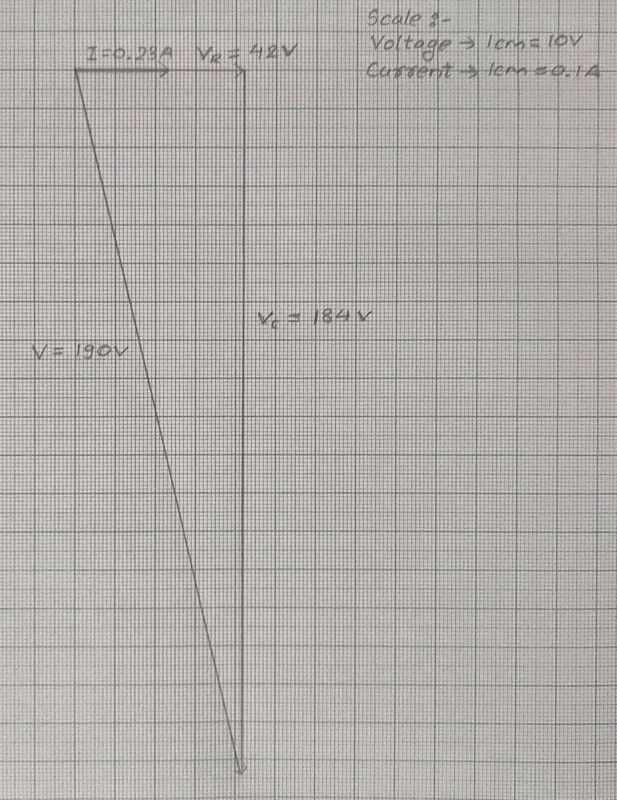

**4.11 Results:**

* + 1. Resistance of the circuit = R= **182.6 Ω**
    2. Capacitance of the circuit = C = **3.9 μF**
    3. Power factor of the circuit = cos ø= **0.2099 rad**

**EXPERIMENT NO. 5**

### Direct Loading Test on Single Phase Transformer

* 1. **Given Parameters:**

|  |  |  |  |  |  |  |
| --- | --- | --- | --- | --- | --- | --- |
| **Sr.No.** | **V1 (V)** | **I1 (A)** | **W1 (W)** | **V2 (V)** | **I2 (A)** | **W2 (W)** |
| 1 | 110 | 0.22 | 20*2 | 216 | 0 | 0 |
| 2 | 110 | 2 | 115*2 | 214 | 0.8 | 80*2 |
| 3 | 110 | 3.6 | 220*2 | 210 | 1.7 | 150*2 |
| 4 | 110 | 5.2 | 320*2 | 200 | 2.5 | 260*2 |
| 5 | 110 | 6.75 | 430*2 | 198 | 3.3 | 340*2 |
| 6 | 110 | 8.2 | 525*2 | 192 | 4.15 | 410*2 |

* 1. **Calculations:**

• From circuit diagram, power rating = Q = 1 kVA, rated primary voltage= V1= 110 V, Rated secondary voltage = V2= 220 V

1. Voltage ratio = V1/V2 = **0.5**
2. I1 (rated) = (Q × 103)/ (rated V1) = **9.09 A**
3. I2 (rated) = (Q ×103)/ (rated V2) = **4.54 A**
4. Current ratio = I1/I2 = **2**
5. Percentage Efficiency = [W2/ W1] ×100
6. % Regulation = [(E2 – V2)/ E2] ×100 Where, E2 = Secondary voltage on no load, V2 = Secondary voltage on load

(Note: value of E2 will be same i.e., 220 V for all calculations)

**5.8 Result Table:**

* **Voltage ratio = 0.5**
* **Current ratio = 2**

|  |  |  |  |  |
| --- | --- | --- | --- | --- |
| **Sr. No.** | **Output Current I2 (A)** | **Output Power W2 (W)** | **Efficiency (%)** | **Voltage Regulation (%)** |
| 1 | 0 | 0 | 0 | 1.82 |
| 2 | 0.8 | 160 | 69.57 | 2.73 |
| 3 | 1.7 | 300 | 68.18 | 4.55 |
| 4 | 2.5 | 520 | 81.25 | 9.09 |
| 5 | 3.3 | 680 | 79.07 | 10 |
| 6 | 4.15 | 820 | 78.1 | 12.7 |

**5.9 Graphs:**

**Draw following graphs by selecting appropriate scales.**

1. **% Efficiency (on Y-axis) Vs. Power Output (on X-axis)**
2. **% Voltage Regulation (on Y-axis) Vs. Output Current (on X-axis)**

**EXPERIMENT NO.6**

**Verification of Voltage and Current Relations and Power Calculations in Three Phase Star and Delta connected balanced Loads**

* 1. **Given Parameters:**

**For Star connection**

|  |  |  |  |  |
| --- | --- | --- | --- | --- |
| **Sr. No.** | **Line Voltage (V)** | **Phase Voltage (V)** | **Line Current (A)** | **Phase Current (A)** |
| 1 | 354 | 200 | 0.89 | 0.89 |
| 2 | 392 | 224 | 0.93 | 0.93 |
| 3 | 440 | 245 | 1 | 1 |

**For Delta connection**

|  |  |  |  |  |
| --- | --- | --- | --- | --- |
| **Sr. No.** | **Line Voltage (V)** | **Phase Voltage (V)** | **Line Current (A)** | **Phase Current (A)** |
| 1 | 448 | 448 | 2.2 | 1.3 |
| 2 | 448 | 448 | 2.9 | 1.7 |
| 3 | 448 | 448 | 3.7 | 2.1 |

* 1. **Calculations:**

For star connection:

VL = √3 VPH [calculate line voltage for each reading by using this formula and phase voltage reading]

1. VL1 = √ 3VPH1 = 346.410 V, Ptotal = √3 VL1 IL1 cosø = **533.99 W**
2. VL2 = √ 3VPH2 = 387.979 V, Ptotal = √3 VL2 IL2 cosø = **624.95 W**
3. VL3= √ 3VPH3 = 424.352 V, Ptotal = √3 VL3 IL3 cosø = **734.99 W**

For delta connection:

IL=√3 IPH [calculate line current for each reading by using this formula and phase current reading]

1. IL1 = √ 3IPH1 = 2.25 A, Ptotal = √3 VL1 IL1 cosø = **1745.9 W**
2. IL2 = √ 3IPH2 = 2.94 A, Ptotal = √3 VL2 IL2 cosø = **2281.31 W**
3. IL3 = √ 3IPH3 = 3.63 A, Ptotal = √3 VL3 IL3 cosø = **2816.73 W**

**6.8 Result Table:**

|  |  |  |  |  |  |  |  |
| --- | --- | --- | --- | --- | --- | --- | --- |
| **Sr.**  **No.** | **Line**  **Voltage**  **Given**  **Star (V)** | **for** | **Line**  **Voltage Calculated for Star (V)** | **Line**  **Current**  **Given for**  **Delta (A)** | **Line**  **Current**  **Calculated for Delta**  **(A)** | **Total**  **Power**  **Consumed by Star**  **Load (W)** | **Total**  **Power Consumed by Delta**  **Load (W)** |
| 1 | 354 |  | 346.41 | 2.2 | 2.25 | 533.99 W | 1745.9 W |
| 2 | 392 |  | 387.97 | 2.9 | 2.94 | 624.95 W | 2281.31 W |
| 3 | 440 |  | 424.35 | 3.7 | 3.63 | 734.99 W | 2816.73 W |

1. **9 Phasor Diagrams:** 
   * **Phasor diagram for star**

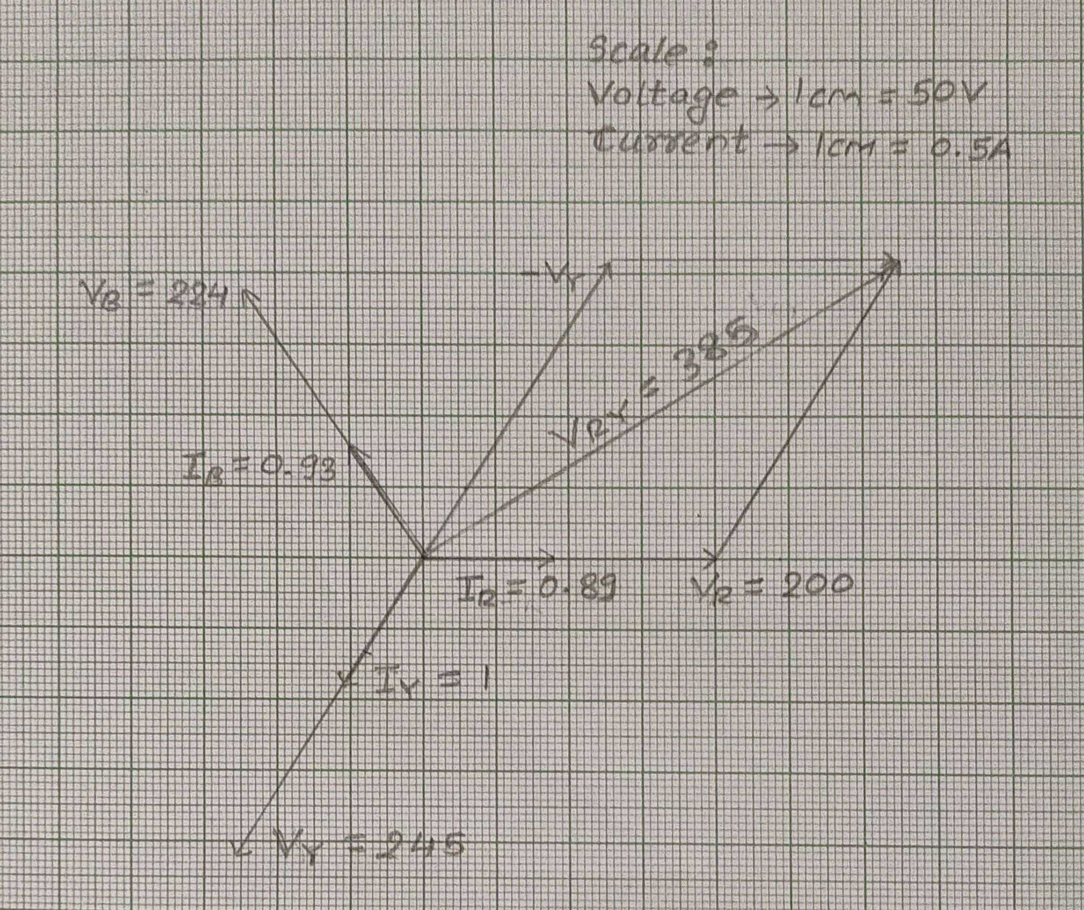

* + **Phasor diagram for delta**

